**Oracle Apex Project Upload inside GitHub**

**Step 1:** Create a GitHub Repository

* Go to GitHub and log in to your account.
* Sign in the top right corner and select "New repository".
* Choose a name for your repository, add a description (optional), and configure other settings as needed. Make sure to initialize the repository with a README file if you want to add one.

**Step 2:** Export your Oracle APEX Application.

* Log in to Oracle APEX.
* Navigate to the application you want to export.
* Click on "Export" from the "Utilities" menu.
* Choose the appropriate export format (typically, you'll use the "Export to Application Archive" option).
* Save the export file (.zip file) to your local machine.

**Step 3:** Organize your GitHub Repository

* Navigate where you want to clone your git repo
* In my case: D:\Git Project.
* Entry into “Git Project”- folder and right click mouse
* Select Open Git Bash [**need to install git bash in your local machine**]
* Go to GitHub > See “Code” button > Click and copy HTTPS URL
* Now write code:

Git clone <https://github.com/biplobhasan92/ApexDemoProject.git>

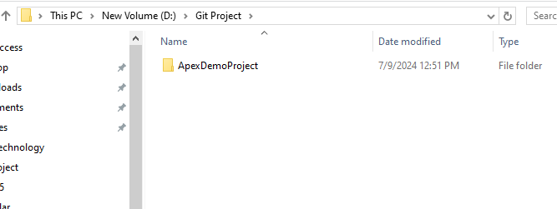

* After Clone you can see folder like this in local machine
* Now place your Oracle apex project into ‘ApexDemoProject’
* Navigate your repo from git bash. ‘cd ApexDemoProject’
* Write command ‘git add exported_file.sql’
* git commit -m "this is comments"
* git push origin main
* after hit push you can see now your project inside GitHub like this.

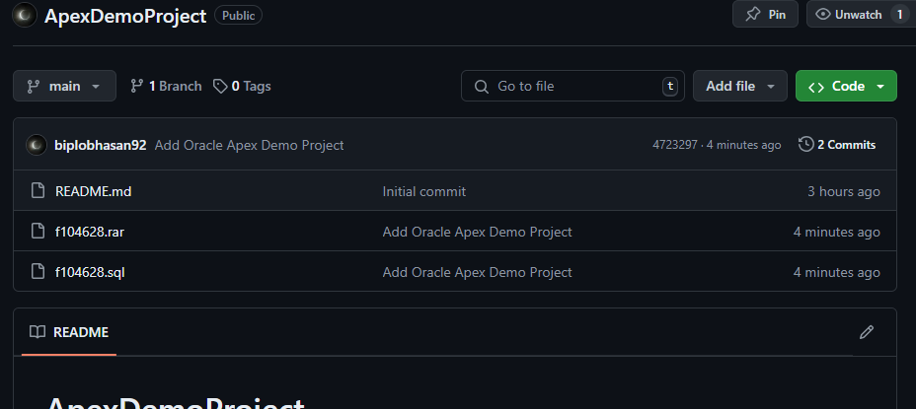

Note: After installing **git bash** at first time user need **log In** in git bash using his GitHub user name and password using related command. Login process is not explain here.